IRIS DATASET REPORT
1.Plot distribution of numerical features (Histograms)
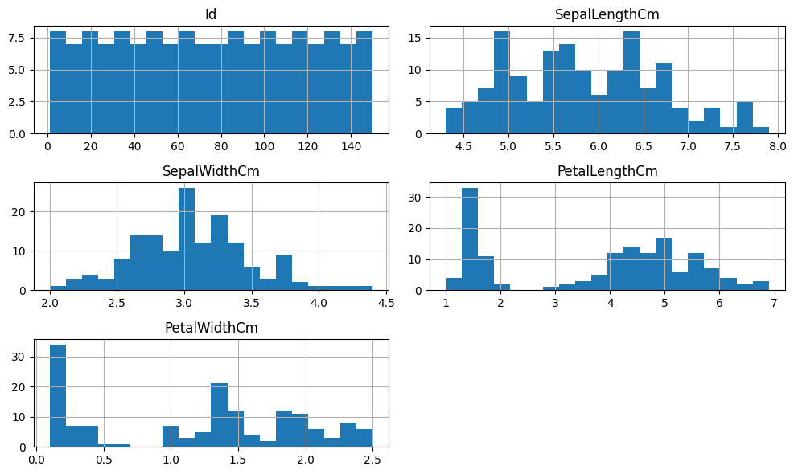
- Features follow *near-normal distributions*
- Petal features show *better class separation*
- No extreme skewness observed
2.Analyze categorical features (Count Plot)
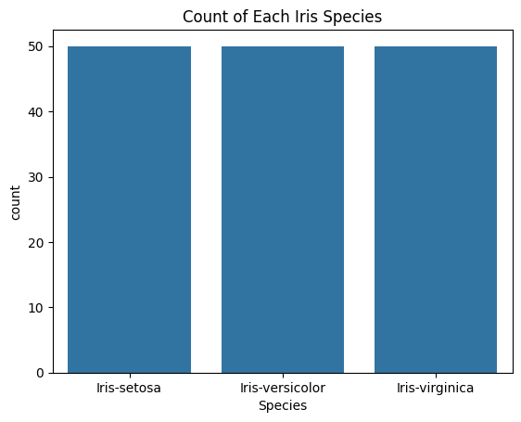
- Dataset is *balanced*
- Each species has equal number of samples
- No class imbalance issue
3.Box plots to identify outliers
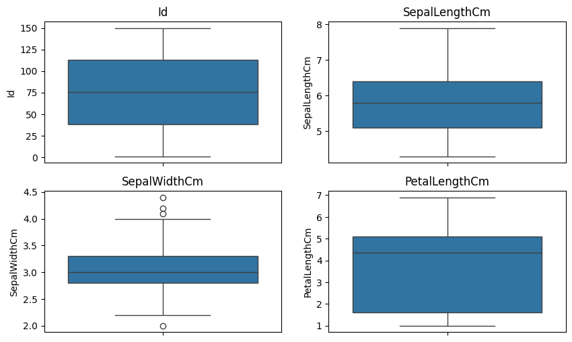
- Minor outliers present in *sepal width*
- Petal features have *clean distributions*
- No need for outlier removal
4. Correlation heatmap
- Strong correlation between *petal length & petal width*
- Sepal features are weakly correlated
- Multicollinearity minimal
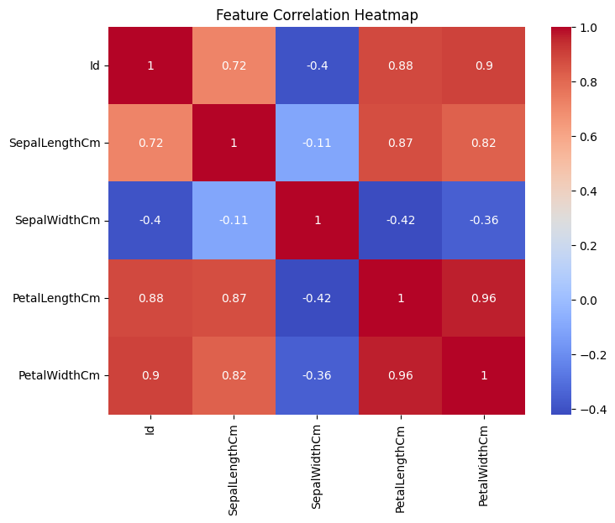
5.Feature importance using correlation with target
- Petal width has *highest correlation*
- Petal length is second most important
- Sepal width contributes least
6.Important features for prediction
- Petal Width
- Petal Length
- Sepal Length
7.Final Summary
- Dataset is *clean and balanced*
- No major missing values or extreme outliers
- Petal features* are strongest predictors
- Strong correlation between petal dimensions
- Suitable for *classification models* like Logistic Regression, SVM, Decision Tree

XXXXXXXXXXXXXXXXX THANK YOU XXXXXXXXXXXXXXX

